**Augusta Historical Museum**

**Annual Chili Supper & Pie Auction**

**$8**

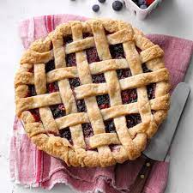 

**Thursday, November 17th**

**Supper @ 5:30PM – Pie Auction to follow**

***Join us as we raise funds for the Historical C.N. James Cabin!***

**Augusta Senior Center- 640 Osage**